BUILDING DOCKER IMAGE

sekarang demo menggunakan python

buat folder baru di workspace



masuk ke dalam folder yang di buat

cd my-phython-app/

buat projek

sudo nano app.py  


paste coding ini di dalam app.py  
from flask import Flask, jsonify

app = Flask(__name__)

@app.route('/hello', methods=['GET'])

def hello_world():

response = {

"return_code": 200,

"message": "hello world"

}

return jsonify(response)

if __name__ == '__main__':

app.run(host='0.0.0.0', port=5000)

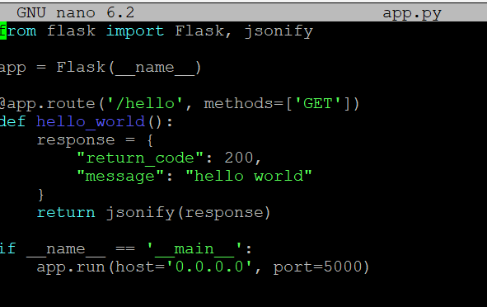

sudo nano Dockerfile



copy perintah ini  
# Use an official Python runtime as a parent image

FROM python:3.9-slim

# Set the working directory in the container

WORKDIR /app

# Copy the current directory contents into the container at /app

COPY . /app

# Install any needed packages specified in requirements.txt

RUN pip install --no-cache-dir flask

# Make port 5000 available to the world outside this container

EXPOSE 5000

# Define environment variable

ENV NAME=World

# Run app.py when the container launches

CMD ["python", "app.py"]

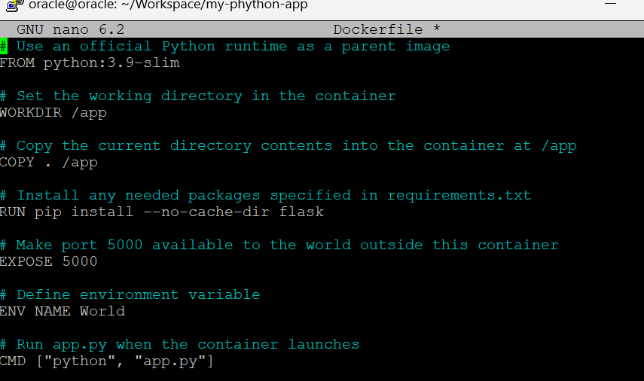

jika sudah selesai buka file nya di vscode

docker build -t My-phython-app .



berhasil di build  
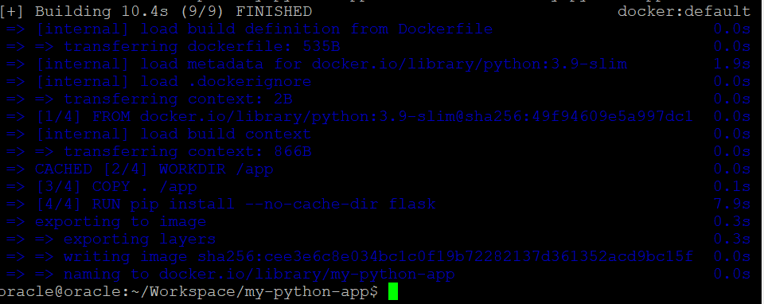

lalu buka cek docker images

docker images

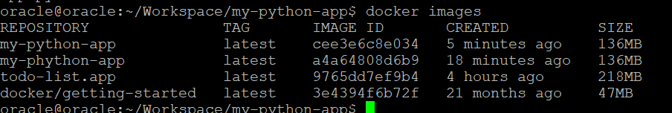

cari file yang baru di buat tadi. kebetulan ada file sama yang ada di pling atas

oracle@oracle:~/Workspace/my-python-app$ docker run -dp 5000:5000 --name python-app-container my-python-app



docker ps

image sudah jadi



buka browser dan tada sudah terinstall

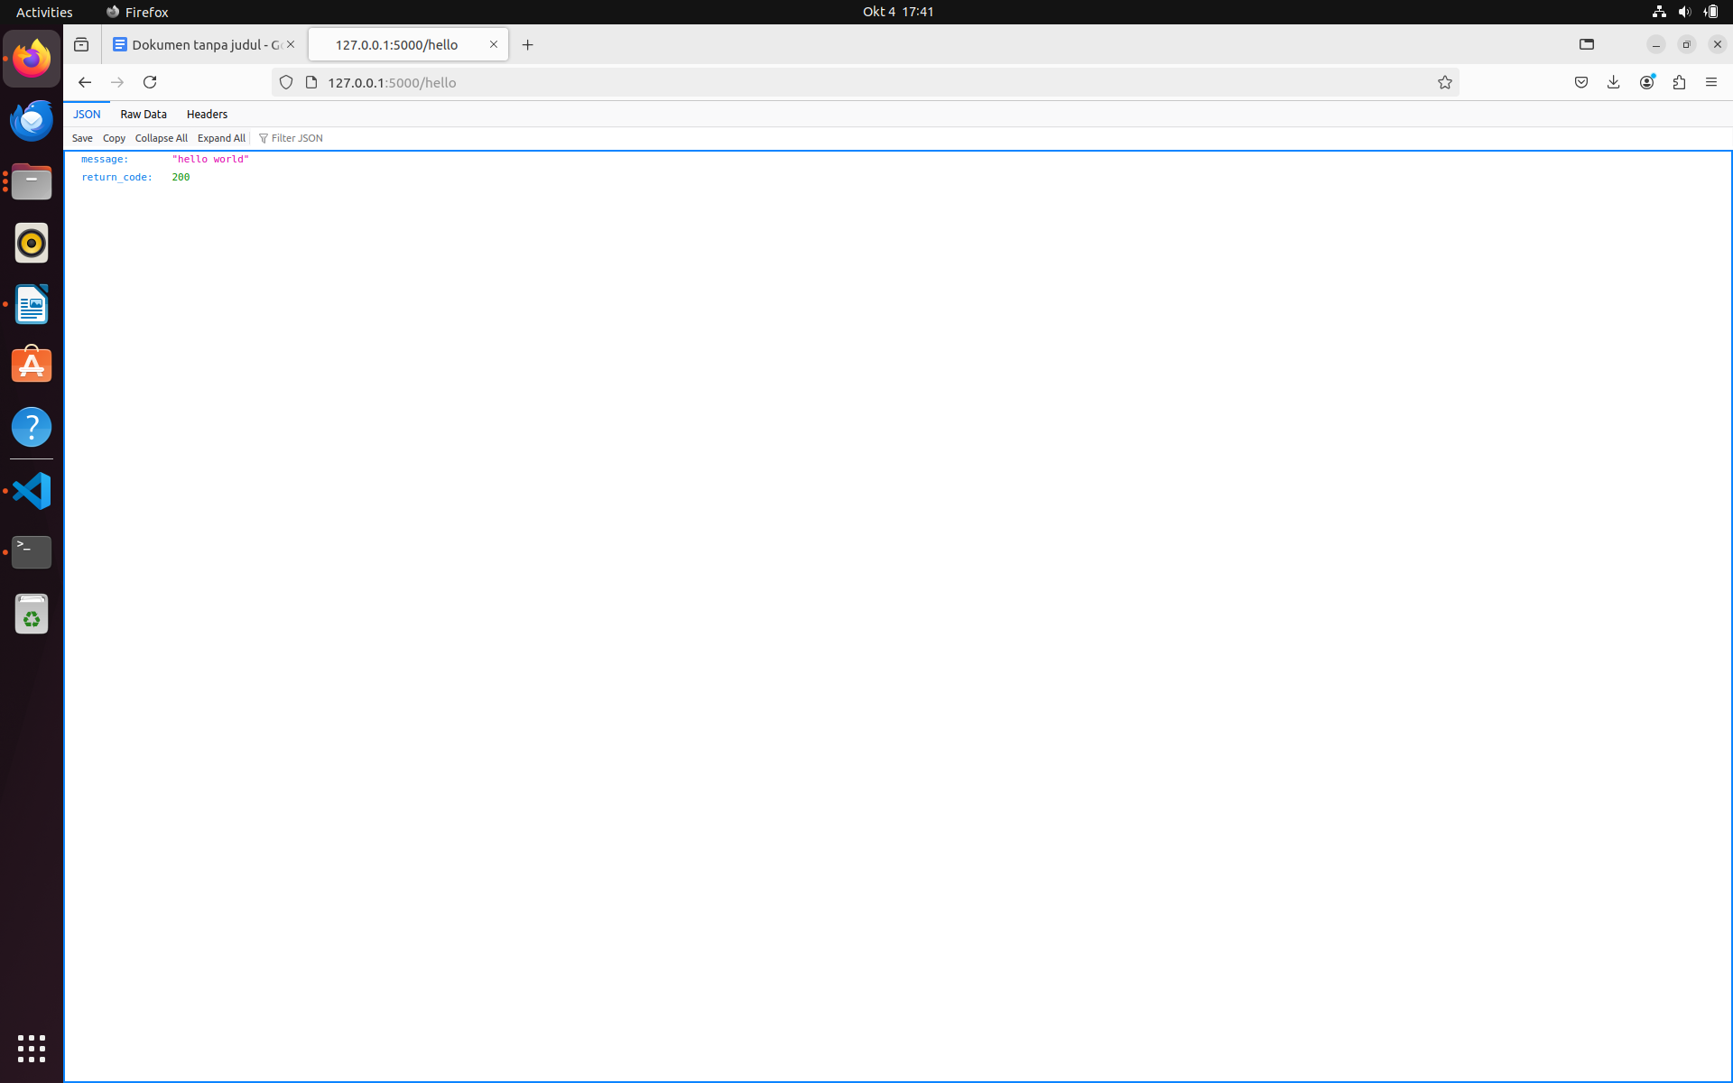

MASIH GAGAL TUGAS NYA

T-T